Installation and Setup of CCA-200 Benson Mini Audiometer with AssessorSuite

Prerequisites
IE Mode For Microsoft Edge
1) With the Microsoft Edge browser, log into Assessor.ei1.com and click on "Administer an Audiometric Exam"
2) Navigate to the top right of the browser to the three horizontal dots and select “Reload in Internet Explorer mode”
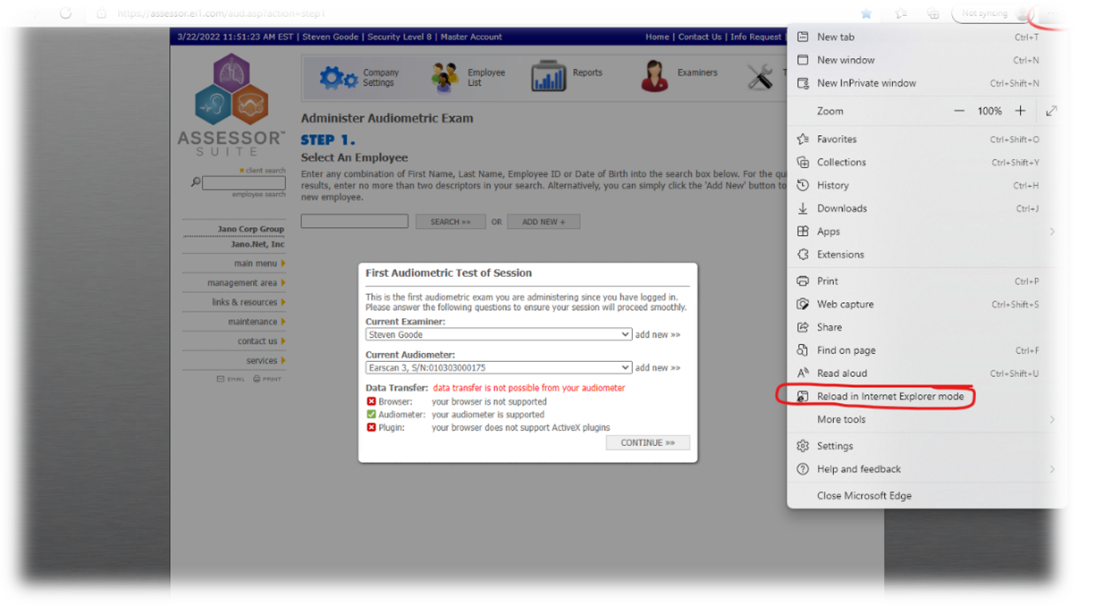
3. Edge will reopen into IE mode assuming your IT group hasn’t turned off this functionality.
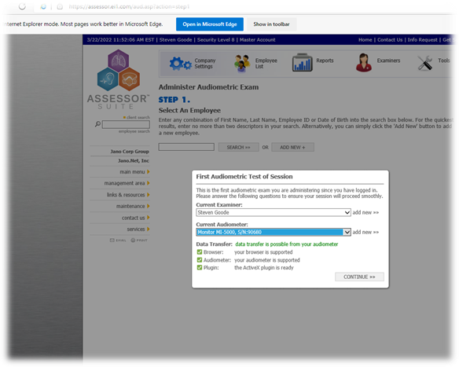
Eltima Virtual Serial Port
Below is the link to the download for the Eltima Virtual Serial Port. You will need to acquire a license to use the virtual serial port and download the software.
https://www.eltima.com/products/vspdxp/?gclid=Cj0KCQiAtICdBhCLARIsALUBFcGjpd3exSnSxpuON53KNy7iepj48RPR3K2JaDp36MvKc0_YpsuPvNkaAqkXEALw_wcB

Installation
- Complete CCA-200 software installation as usual.
- Install the Eltima (or other virtual serial port) software.
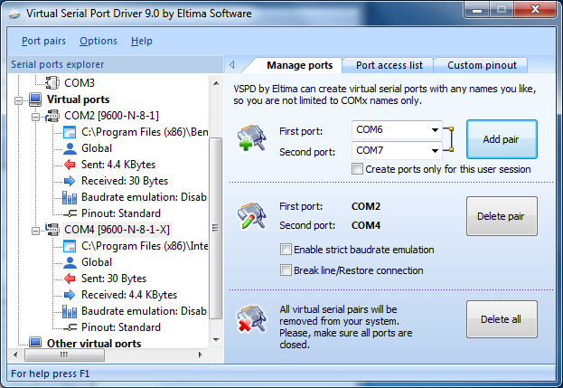
- Create a COM port pair for the two programs (usually between COM2 and COM4).
- Modify %ProgramData%\Benson Medical Instruments\CCA-200\bul\bul_shared.ini to include:
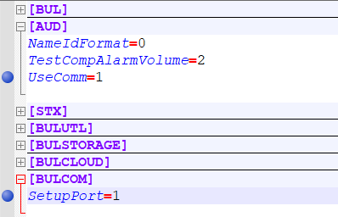
[AUD]
UseComm=1
[BULCOM]
SetupPort=1
  - Add the [BULCOM] section if it does not already exist.
  - Note: SetupPort is indexed to 0, so SetupPort=1 is actually telling the CCA-200 virtual port to use COM2
  - Optional settings if needed:
SetupBaud=?
SetupData=?
SetupStop=?
SetupPar=?
- Open the CCA-200 software.
At the Welcome screen, choose the database interface: FOSHM/RA500 Protocol, then click OK.
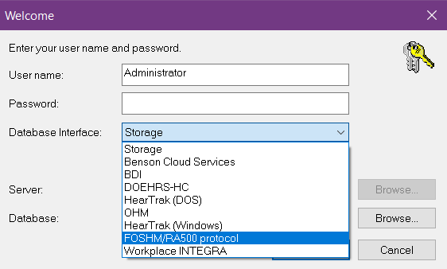

Synchronization
Now we move to Assessor https://assessor.ei1.com and add the audiometer to the account in order to have them communicate.
1. Login to Assessor Suite using your login credentials.
2. Next, go to Audiometers on the front page.
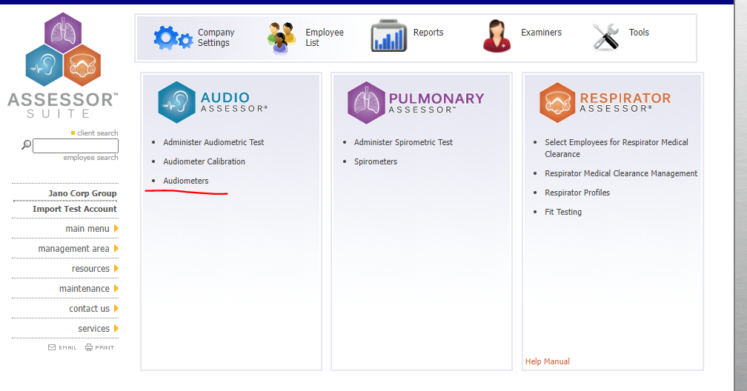
3. Then select the plus button next to “Manage Audiometers”
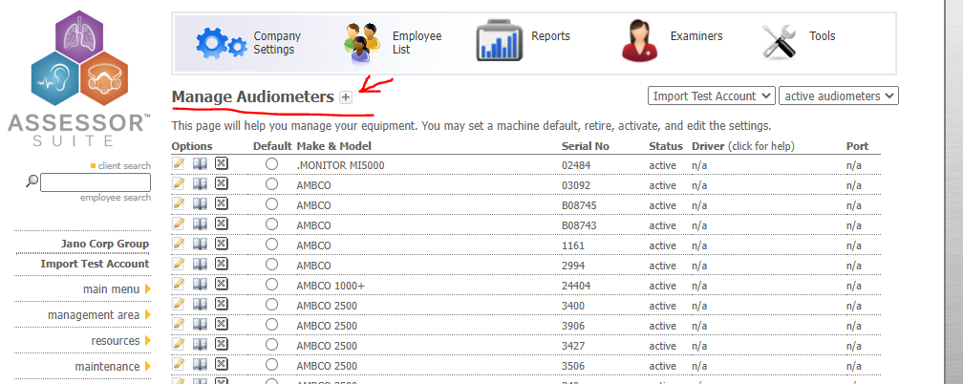
4. Next, fill in the audiometer record with the necessary information. Be aware of the Driver and the Port sections and be sure to select “Benson CCA-200” for the Driver and select the appropriate COM port that you set up in the Eltima Virtual Serial Port step.
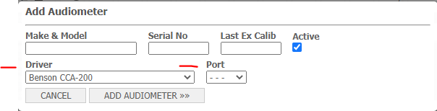
5.Finish by selecting “Add Audiometer”.

Testing
Now we all set up to administer a test using the Benson audiometer.
1. First go back to the main screen and select “Administer Audiometric Test”
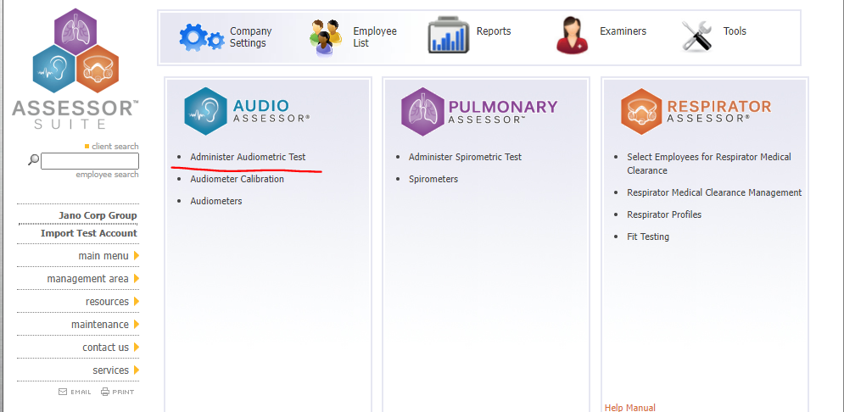

2. Next, if this is your first test, then submit the Daily Calibration, otherwise search for the employee in your account.
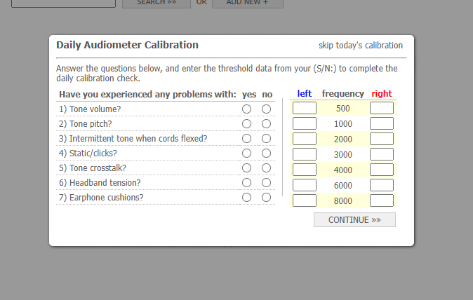
3. Then Fill out the Audiometric Questionnaire.
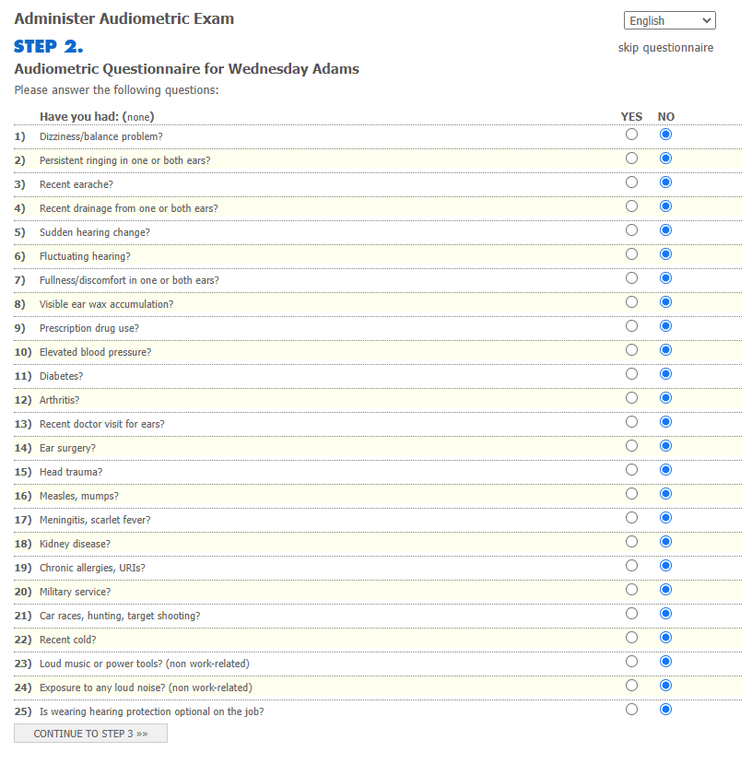
4. Now, you should get to the testing screen. Make sure that the data fields are correct before continuing. Then, in the “Audiometer” drop down menu, make sure to select the Benson unit you are using.
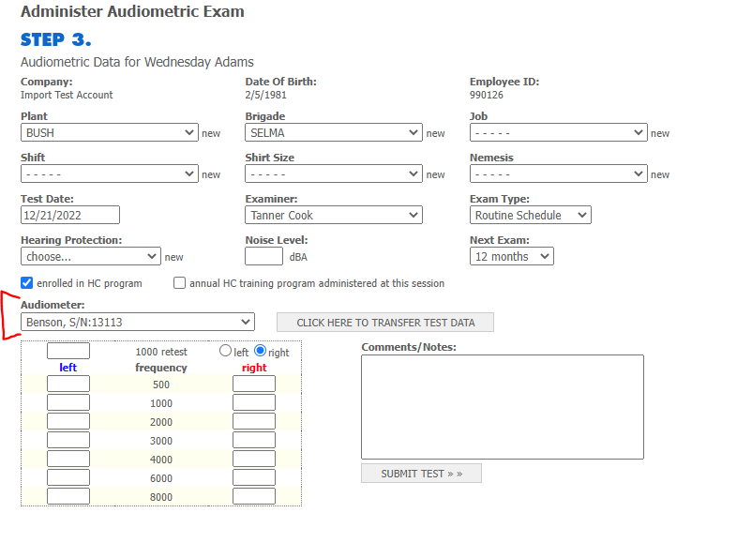
5. Next go back to the Benson CCA program and begin the test. Once the test is completed, then go back to Assessor and click “Click here to transfer Data” button. This will upload the test to the account.
