RA660 Export Procedure
Thursday, September 14, 2023
11:43 AM

- Open Hearcon
- Navigate to Utilities
- Click Export Data
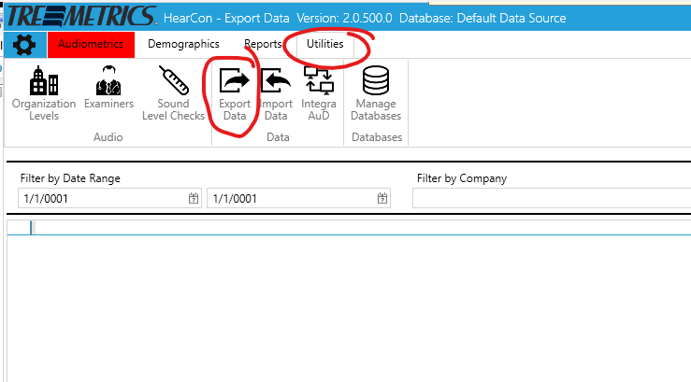

- Select a Date Range and Company
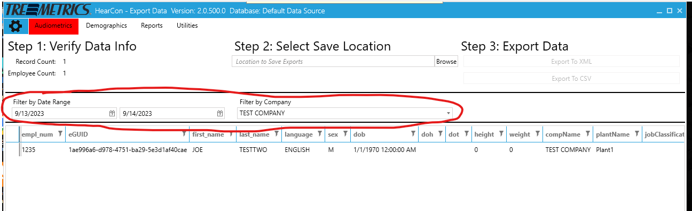

- Select a save location (Desktop is fine)
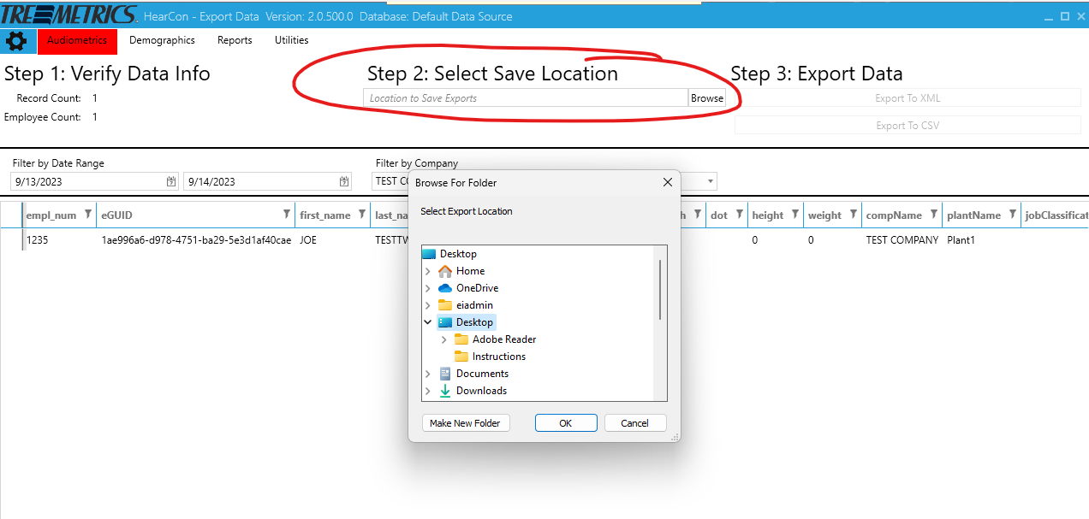

- Click Export to CSV
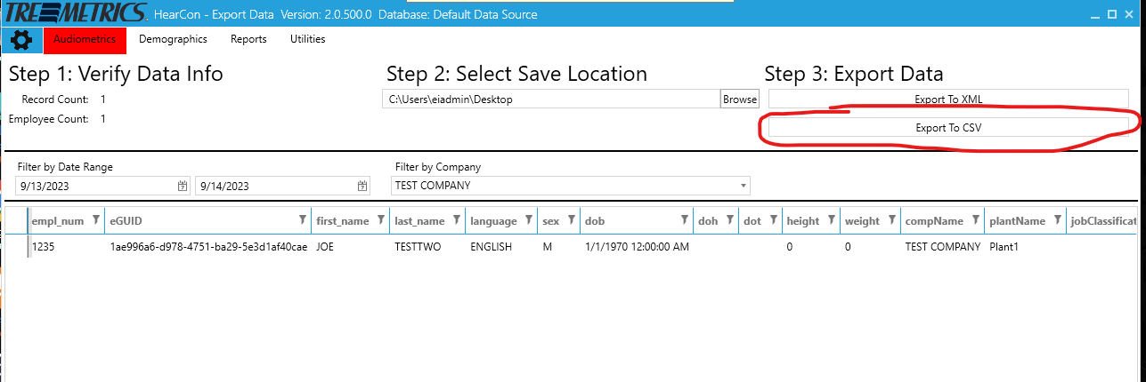

- Retrieve export.csv from desktop or save location.
