
Environmental, Health and Safety Solutions.™
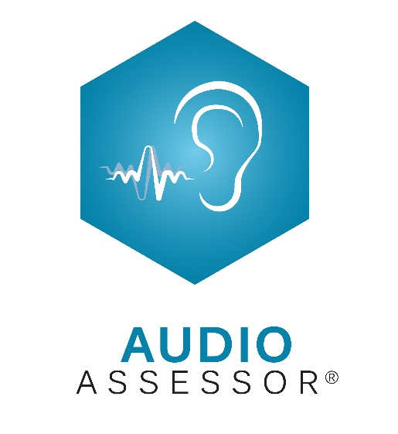
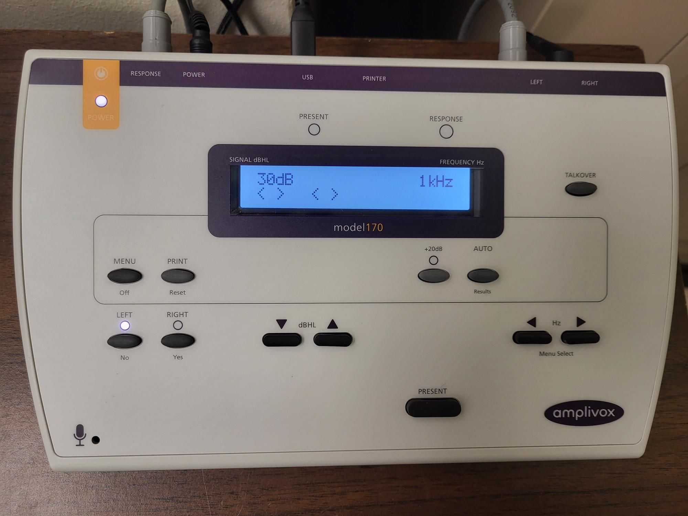
USING THE AMPLIVOX
170 AUDIOMETER WITH AUDIOASSESSOR®
V4.7.2025
Switching the Audiometer On and Off
On the left side of the audiometer’s back panel is a small switch. Press and hold the switch to turn the audiometer On. To turn the audiometer Off, press and hold the MENU key, then use the FREQUENCY right-arrow key to select “Switch off?” Press and release the YES key, then release the MENU key. The screen will remain backlit but will be blank…this is the Off position.

Set the Audiometer’s Testing Parameters
This needs to be done only once. Press and hold the MENU key throughout this entire process. Use the FREQUENCY right-arrow key to toggle through the following parameters:
- Switch Off? – toggle to the next setting.
- Clear test? – toggle to the next setting. Remember this parameter as it will be used often!
- Save audiogram to (1) – toggle to the next setting.
- Load audiogram to (1) – toggle to the next setting. Saving and loading audiograms into the audiometer is unnecessary with AudioAssessor®.
- Contrast – this can be adjusted using the SIGNAL up and down keys. Then toggle to the next setting.
- Print audiogram? – this is unnecessary with AudioAssessor®. Toggle to the next setting.
- Use 250Hz in auto? – press the NO key, then toggle to the next setting.
- Use 1K5Hz in auto? - press the NO key, then toggle to the next setting.
- Use 8KHz in auto? – press the YES key, then toggle to the next setting. This enables testing of 8000 Hz.
- Use familiarization? – if YES is selected, testing a person in automatic mode will begin with a trial run at 1000 Hz starting from -10 dB HL. This allows the patient to become familiar with taking a hearing test. This could be a helpful learning process for someone with no prior experience taking a hearing test and could temporarily be set to YES for that specific patient. But leaving it on YES for all patients is unnecessary for the experienced and will add testing time. It’s recommended that the setting be NO. Toggle to the next setting.
- Store on 2 of 3 in auto? – press the NO key, then toggle to the next setting.
- Pulse in Manual? – press the YES key, then toggle to the next setting. Pulsed tones are easier to hear than Continuous tones, especially for those with tinnitus and is recommended.
- 2 of 3 in auto? – press the YES key, then toggle to the next setting.
- Default level – the default is 30 dB HL. Use the dBHL up-arrow key increasing to 40 then toggle to the next setting.
- Select printer -- toggle to the next setting.
Release the MENU key to save the settings for this and all future tests.

Daily Calibration Check
Login to AudioAssessor®. On the Main Menu screen, click Administer Audiometric Test.
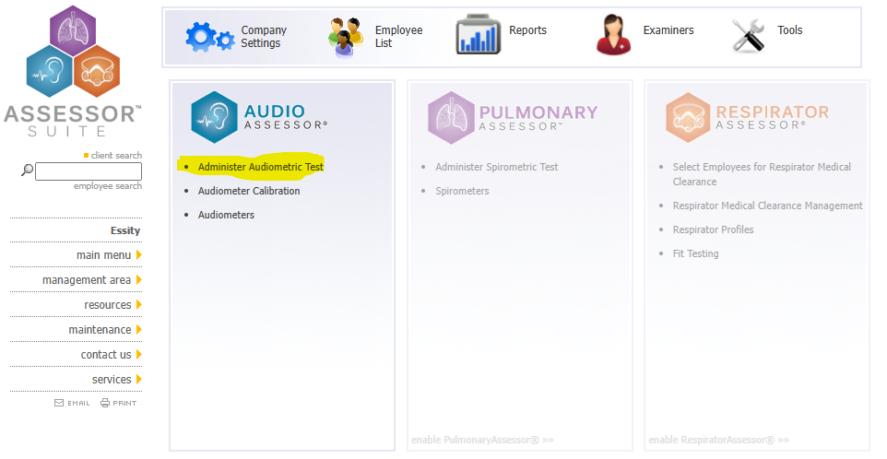
At the first login of the day, AudioAssessor® will prompt a daily calibration check. On this “session check” pop-up screen, select the Examiner and the Audiometer, then click CONTINUE.
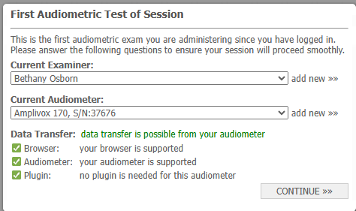

A Daily Audiometer Calibration pop-up screen will appear.
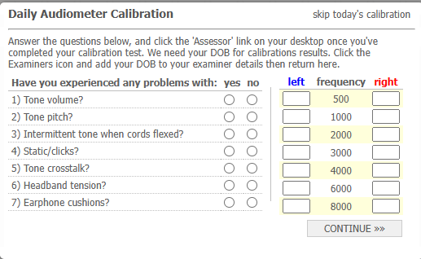
A daily calibration check consists of a Self-Listening Check and an Output Check. The Self-Listening Check is conducted first. When the audiometer is first turned on, or when the previous test has been cleared from memory, the audiometer will be in Manual testing mode and defaults to the Left ear. Press the Patient Response button…the RESPONSE light on the audiometer should come on.
Place the headphones on yourself. Then use the FREQUENCY and PRESENT keys to present all frequencies from 500 Hz through 8000 Hz in the left ear…do the frequencies sound like tones? Use the dBHL up and down keys…do the tones get louder and softer? Holding down the PRESENT key and gently wiggling the headset cord, you should not hear static. Nor should you hear the tone fading in and out when wiggling the cord.
Check for crosstalk…you should hear the tone only in one ear, not in both ears at the same time. Then press the RIGHT key to switch to the right ear repeating this process. If you hear an issue, then stop, do no testing, and contact Steven Goode and/or Gregg Moore…it may be time for an audiometer repair.
If there are no issues, then click the “no” buttons on the Daily Audiometer Calibration screen. Then on the audiometer, press and hold the MENU button, use the FREQUENCY right-arrow key to select “Clear test?”, press and release the YES key, then release the MENU key.

Now for the Output Check. Place the headphones on the bio-acoustic calibrator with the right (red) headphone on the right coupler and the left (blue) headphone on the left coupler as pictured below.
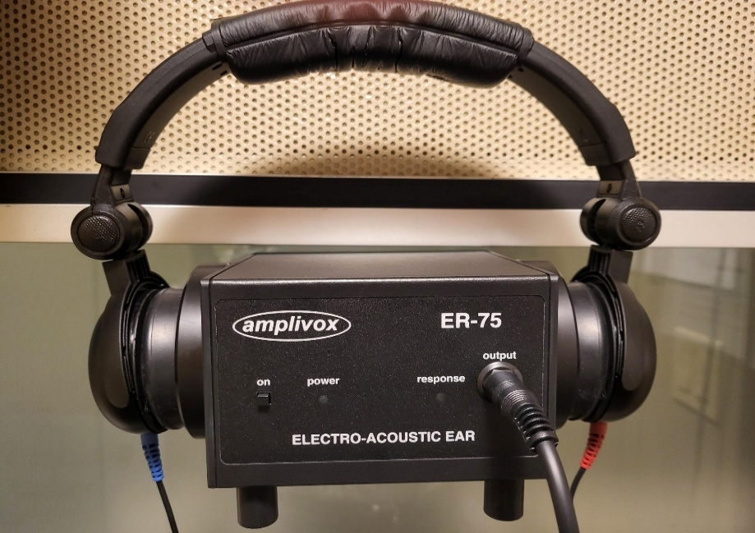

Unplug the patient response button from the sound booth’s interior jack panel and plug the bio-acoustic calibrator’s Output cable into the same jack. Be careful to only handle these by the plug, not the cables, as pulling on the cables can damage them. Turn on the bio-acoustic calibrator. To initiate the automatic test, press the AUTO button. When the test is complete, the audiometer’s screen will say “Test finished.”
On your computer’s desktop, locate and double-click the “Send to Assessor” icon. A screen will open for 5 seconds automatically transferring thresholds from the audiometer into the Daily Audiometer Calibration screen.
The calibration screen should now look like this (an example only, your numbers may look different):
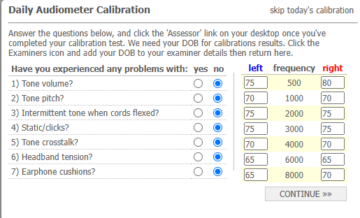
Click the CONTINUE button. AudioAssessor® will compare today’s results against the baseline. Thresholds must be within 5 dB of the calibration baseline at all test frequencies to pass the Output Check. If the Output Check fails, you will see the following screen:
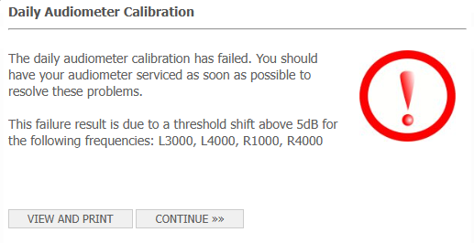
Notice in this example that it failed in the left ear 3000 & 4000 Hz, and in the right ear at 1000 & 4000 Hz. If the Output Check fails, then do the following:
- Make sure the headphones are positioned correctly on the bio-acoustic calibrator.
- Consider changing the battery as a weak battery can cause spurious results. Have spare batteries readily available.
- Make sure the bio-acoustic calibrator’s response cable is well-inserted into the jack.

On the audiometer, clear the test and try another AUTO test. While the audiometer is testing, go to the “Main Menu” screen in Assessor, then click Administer Audiometric Test to get to the Step 1 page. On the bottom of the Step 1 page, click the word “Calibration” (see the picture below). This will pull up another Daily Audiometer Calibration screen into which the 2nd set of thresholds will be transferred.
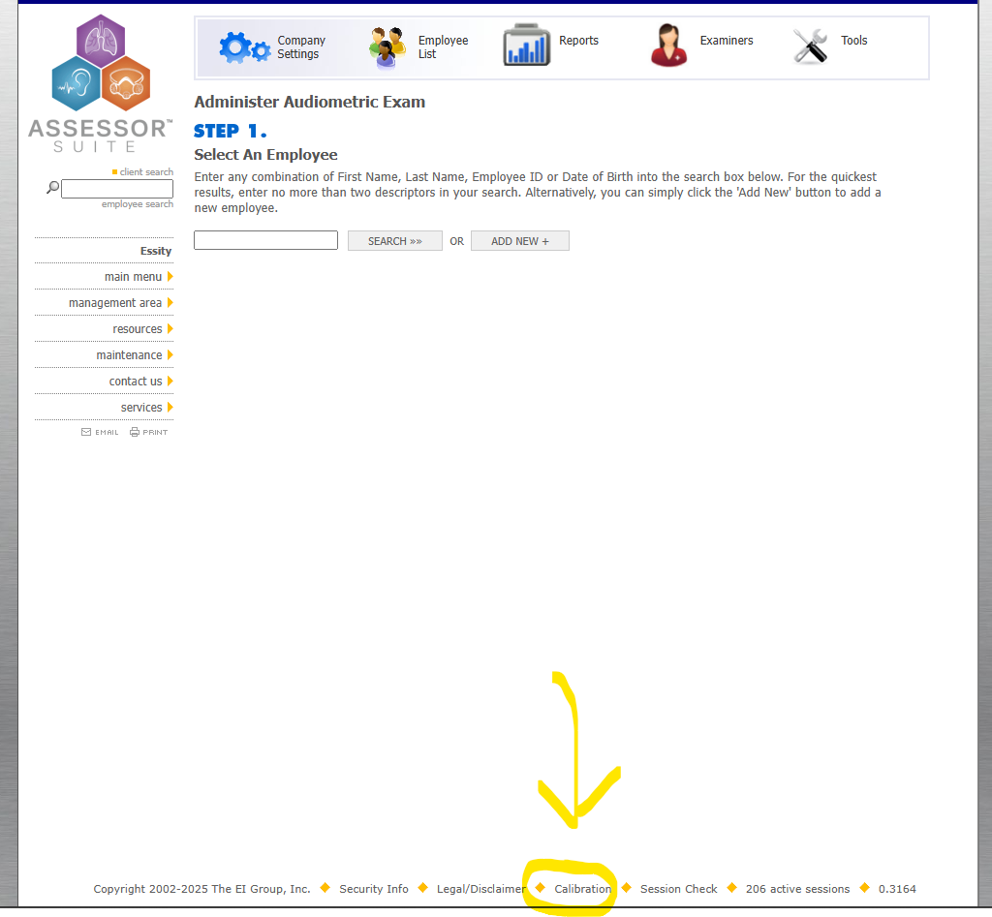
If the Output Check passes, you will see the following screen. Press CONTINUE.
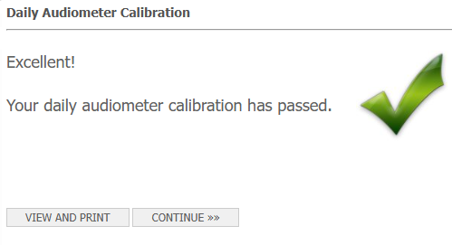
But if the 2nd Output Check also fails, then no testing of patients until the issue is resolved. Contact Steven Goode and/or Gregg Moore as it may be time for an audiometer calibration or repair.

Assuming both the Self-Listening Check and Output Check pass, then prepare the audiometer for testing patients as follows:
- Clear the test from the audiometer. This is done by pressing and holding the MENU key, using the FREQUENCY right-arrow key toggling to “Clear test?”, pressing and releasing the YES key, then releasing the MENU key.
- Turn off the bio-acoustic calibrator. Carefully unplug the response cable from the sound booth’s interior jack panel, then reinsert the patient response button into that same jack.
- In AudioAssessor®, either stay on the Step 1 screen or go back to the Main Menu.

Testing Patients in Automatic Mode
On the AudioAssessor® main menu, click Administer Audiometric Test. On the Step 1 screen, enter the person’s last name (the first 3-4 letters of the last name usually work well though sometimes date of birth or first name can also work), then click the Search button. This will populate a list of employees meeting the search criteria. If your patient is on that list, then click GIVE AUDIOGRAM. If the patient is not on this list (perhaps being a new hire), then click ADD NEW – fields marked with a red asterisk are required. Whether an existing or new employee, the screen will then advance to Step 2, an Audiometric Questionnaire. While it’s advisable to complete this, the user has the option to “skip questionnaire” – either completing the questionnaire or skipping it will advance AudioAssessor® to Step 3.
On the Step 3 screen, make any necessary changes using the drop-down menus being sure to choose the proper Examiner. The two most used Exam Types are “Routine Schedule” for the annual hearing test and Baseline but other options are available. Note the two checkboxes “enrolled in HC program” and “annual HC training program administered at this session.” Checking the 2nd box adds verbiage to the Notification Report to document that hearing conservation training was provided at the time of the test. Now it’s time to test the patient so place him in the sound booth.
In pulsed-tone mode, the audiometer presents 5 beeps at a time so it’s important that the patient not press the button more than once per 5-beep presentation. Before placing headphones on the patient, instruct the patient that he will hear beeps which will be soft and somewhat difficult to hear. When the patient hears beeps, he is to press the button once and then completely release it. It sometimes helps to demonstrate how to press and completely release the button. Regardless of the number of beeps, only press the button one time. Then place the headphones on the patient, red on the right ear and blue on the left ear. Press the AUTO button to initiate the test beginning in the left ear then proceeding to the right ear. When the test is complete, the audiometer’s screen will say “Test finished.” The user has the option – strongly recommended – of viewing test results on the audiometer’s screen before transferring them into AudioAssessor®. This is done by pressing the RESULTS key, then using the FREQUENCY keys to scroll through left ear thresholds. Then press the RIGHT key and use the FREQUENCY keys to scroll through right ear thresholds. If all looks appropriate, then it’s time to transfer these thresholds from the audiometer into AudioAssessor®.
On the computer’s desktop, double-click the “Send to Assessor” icon. A screen will open for 5 seconds transferring thresholds from the audiometer into the AudioAssessor® Step 3 page. MAKE SURE THAT THE TRANSFERRED THRESHOLDS MATCH THE THRESHOLDS ON THE AUDIOMETER’S RESULTS SCREEN. IF ONE OR MORE OF THE THRESHOLDS ON THE AUDIOMETER DID NOT TRANSFER CORRECTLY INTO AudioAssessor®, THEN MANUALLY ENTER THE CORRECT VALUE(S) ON THE STEP 3 PAGE.
The next step is to determine if manual testing of one or more frequencies is needed. If so, then clear the test from the audiometer to place the audiometer in manual testing mode. Test as necessary, then manually enter the results into the AudioAssessor® Step 3 page.
When all testing is complete, click SUBMIT TEST on the Step 3 page. AudioAssessor® will then compare the current test to the baseline automatically producing a Notification Report for viewing and printing. Once printed, the user can close the Notification Report then return to the Main Menu.
Clear the test from the audiometer by pressing and holding the MENU key, using the FREQUENCY right-arrow key toggling to “Clear test?”, pressing and releasing the YES key, then releasing the MENU key.

What to do if an Audiometer Error Message Occurs During Automatic Testing
When testing a person in automatic mode, do not walk away from the audiometer! Three error messages can occur during testing and must be addressed in real-time. They are:
- 1kHz match exceeded! – this means that the person failed the 1000 Hz retest. When this happens, the audiometer’s screen will say “1kHz match exceeded!” and give the user the option to retry. Choose YES…for this error never choose NO. This will give the patient a 2nd opportunity to pass the 1000 Hz retest. If he passes, then the audiometer will proceed to test the next frequency as usual. But if the retest fails, thus giving the same error message, then all test results are invalid and must not be transferred into AudioAssessor®. At this point, clear the test from the audiometer, reinstruct the patient, and try again…or wait until another day.
- Response always! – this error message occurs when the patient does not fully release the response button. The audiometer’s screen will say “Response always!” and give the user the option to retry. Before doing so, reinstruct the patient to press and fully release the button (demonstrate this). Then choose YES to retry. One reinstruction is usually sufficient, but more may be needed. For this error message, never choose NO…keep reinstructing until the patient understands. For a rare few, a completely manual hearing test may be necessary.
- No response! – this occurs when the audiometer’s maximum output of 95 dB HL in automatic mode has been reached but the patient does not press the response button. When this happens, the audiometer’s screen will say “No response!” and give the user the option to retry. If a No Response occurs on the first one or two frequencies tested and this is a person with little-to-no experience with taking a hearing test, then the patient may simply not understand that he needs to press and release the button whenever beeps are heard…reinstruct and then press the YES key to retry. But the more common scenario is that the person’s hearing is worse than 95 dB HL at the current test frequency. It’s often helpful to look at the Employee History screen in AudioAssessor® to see the degree of hearing loss present on past tests. If past hearing tests indicate a severe hearing loss at that frequency, then a No Response at 95 dB HL may in fact be accurate in which case the user may choose NO to not retry. But if this is a major change since the last few tests, then more investigation is warranted before proceeding with the test. The Audiometric Questionnaire completed earlier may yield clues concerning whether a person has recently experienced a significant hearing change.
In any of the situations above, the user has the option to skip the retry by choosing NO…though NO should never be chosen for a 1000Hz Retest failure or a Response Always failure as indicated above. But a no-retry may be the appropriate choice to a No Response situation if it’s believed that the person’s hearing is worse than 95 dB HL. If NO is chosen, then the audiometer skips that frequency going to the next frequency and so on until it has attempted to find a threshold at all test frequencies in both ears. At that point, it will give a 4th error message:
- “Test finished incomplete”
Transferring an incomplete test into AudioAssessor® will result in a “99” on the audiogram instead of an actual threshold. In AudioAssessor®, 99 means No Response. If this is accurate, then click the SUBMIT TEST button on the Step 3 page.
However, the user does have the option to manually test one or more frequencies before clicking the SUBMIT TEST button…but only do this after transferring the thresholds obtained in automatic mode because they will have to be cleared from the audiometer before manual testing can occur. After clearing the test, the audiometer will be in Manual testing mode. Use the Right/Left and Frequency keys to select the ear and frequency to be tested. Use the Present key to present the beeps, adjusting the signal down-10, up-5 using the dBHL up and down arrow keys. Do this for as many frequencies as is needed…it isn’t necessary to manually test every frequency if only one or a few test frequencies are of interest. It’s recommended that manually obtained thresholds be written on a piece of paper. Then on the AudioAssessor® Step 3 page, manually input these values if different from the 99 previously transferred. When all is in place, click the SUBMIT TEST button.

NOTE: there is a button on the audiometer labelled “+20dB”. This increases the maximum output of the audiometer from 95 to 115 dB HL but only in manual testing mode. However, it is strongly advised to not test above 95 dB HL. A human auditory system so severely impaired that it can’t detect a 95 dB HL signal can behave unpredictably at higher dB HL levels such that physical pain is quite possible. For non-clinical testing, it is not worth the risk. If it is necessary to obtain thresholds at intensity levels higher than 95 dB HL, then send the person to a local Audiologist skilled in such matters.

