How to Change the Audiometer Calibration Date and Reset the Daily Biological Calibration Check Baseline

OSHA, MSHA and FRA require annual audiometer calibration. It is not unusual that minor adjustments are made which can affect the results of the daily biological calibration check. Therefore, it is necessary to reset the biological calibration check baseline. This is easily accomplished.
Immediately following the audiometer calibration, change that audiometer’s calibration date in AudioAssessor. On the Main Screen, click Audiometer Calibration:

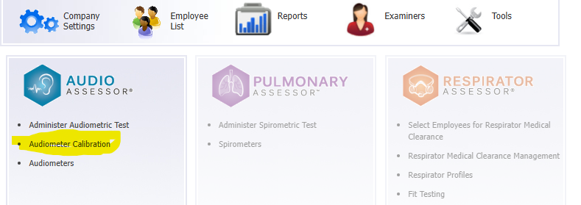

The screen below will appear. Click on the small notepad icon for the newly calibrated audiometer:

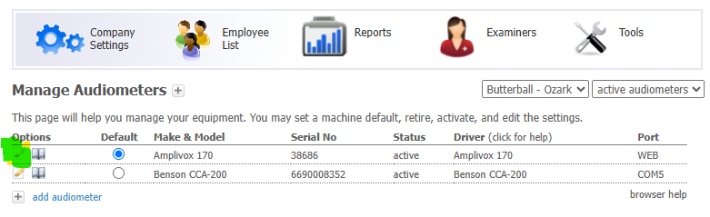

On the next screen, change the date and then click Update Audiometer:

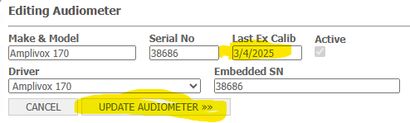

Then, run a new daily calibration check and transfer that data into AudioAssessor.
The next step is to reset the baseline for the daily biological calibration check. On the Main Menu, click Audiometer Calibration. Then click the small open-book icon:

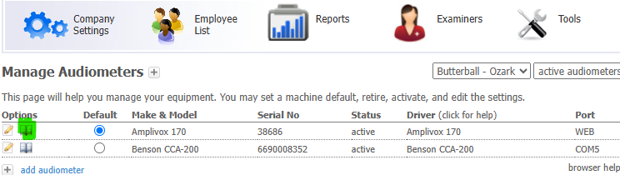

The "Audiometer Calibration History" screen will pop up. The test immediately following the audiometer calibration becomes the new baseline. Since the audiometer was calibrated on 3/4/2025, the next test was on 3/5/2025. Click on the third icon. If hovering over it, it will say "Make This A Baseline":

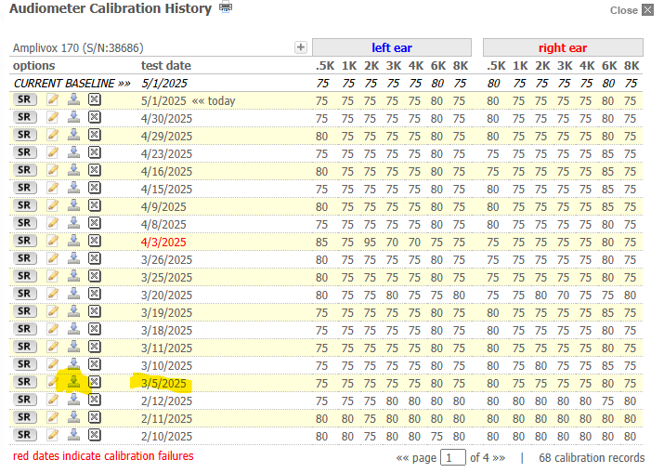

Click the Set button:

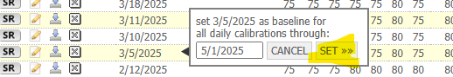

The calibration baseline is now reset (and notice that the values prior to 3/5/2025 do look a little different).

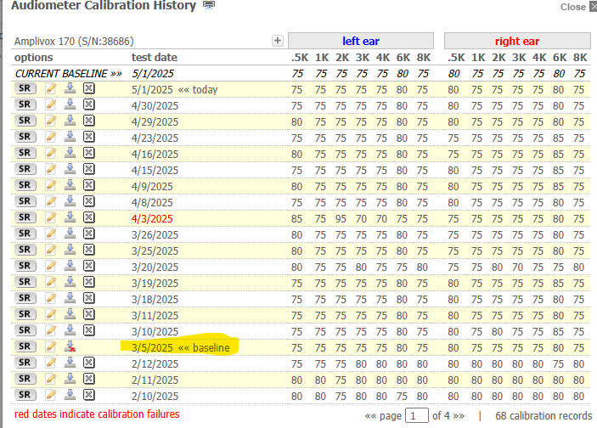

From this point forward, all daily biological calibration checks will be compared to the reset baseline.
To pass the check, all thresholds must be within plus-or-minus 5 dB of the baseline values. The 4/3/2025 test highlighted in red failed in the left ear at 500 Hz and 2000 Hz. If the daily biological calibration check fails, OSHA requires there be no audiometric testing until the issue is resolved. Failures are typically due to a poorly connected cable, headphones improperly seated on the biological calibrator, or weak batteries….and it’s advisable to have spare batteries readily available. After checking these, run the test again. If it passes, then audiometric testing can proceed. But if it does not pass, then contact the provider of your annual audiometer calibration to inform them of the issue. They can often resolve it.

