Step 1: Login to https://assessor.ei1.com/
Step 2: Click Administer an Audiometric Test
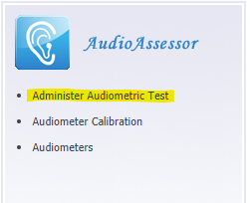

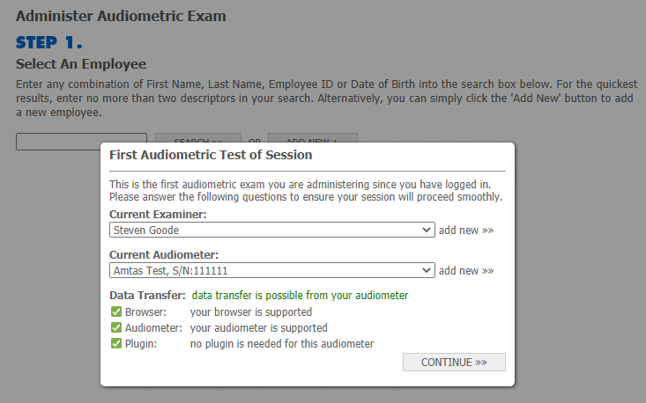
Step 3: Select the Calibrating Examiner (the examiner taking the hearing test for daily calibration purposes) and the Amtas Flex audiometer and click continue. If the “First Audiometric Test of Session” box does not appear, click “session check” at the bottom of the screen to bring it up. Click Continue >>

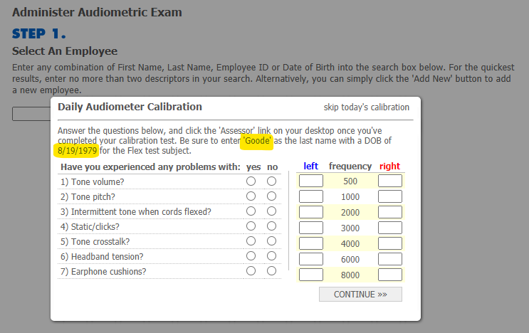
Step 4: The Calibration box should pop up next. If not please click calibration at the bottom of the page to open it. Make note of the Last name and DOB in the instructions. These are the values that need to be entered on the Amtas Flex. Click Continue >>

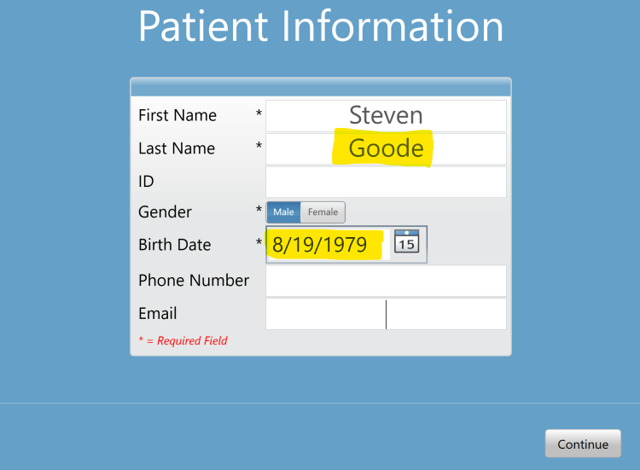
Step 5: Go to the Amtas Flex and have the calibrating examiner take a hearing test (entering the last name and dob exactly as it is displayed in Step 4).

Step 6: Redirect your attention to the “Daily Audiometer Calibration” window on the computer. Once the test is complete the Amtas Flex will automatically upload the test to AudioAssessor. This can take up to two (2) minutes. This occurs in the background. The test values will automatically appear in the calibration window. There is no need to refresh the window or reload the page.
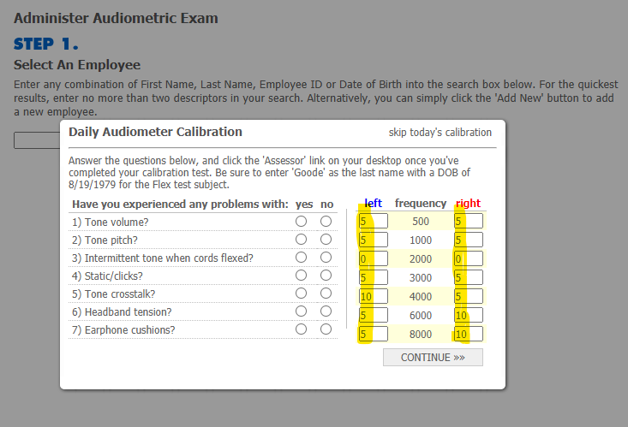

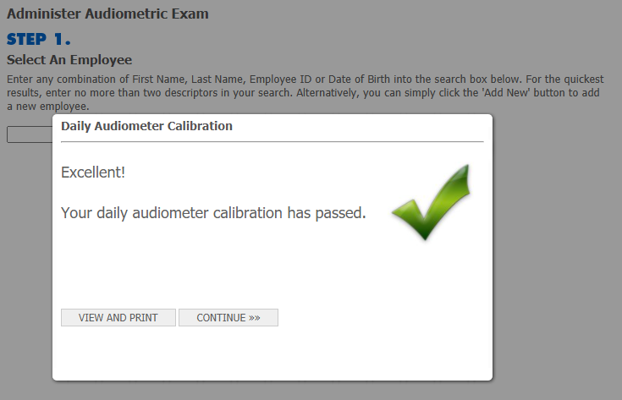
Step 7: Answer the questions and click continue. You are done!

Troubleshooting Tips

TEST NOT UPLOADING AUTOMATICALLY
Step 1: Verify the last name and the DOB entered in the Amtas Flex patient information window for the Calibrating Examiner match the last name and DOB that is listed for the same examiner in Assessor.
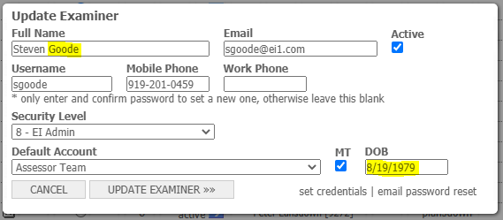

Step 2: Verify that no more than 3 hours have elapsed between the time the test was taken and the time the calibration upload was attempted. If it has been longer than 3 hours, the test results can be manually entered into the calibration history or the calibration will need to be completed again.

BACK-UP CALIBRATING EXAMINER
If the Calibrating Examiner fails the daily calibration, a Back-up Calibrating Examiner may be used to complete the daily calibration.
Step 1: Have the Calibrating Examiner re-take the test. If calibration continues to fail, the Back-up Calibrating Examiner will need to calibrate.
Step 2: Have the initial Calibrating Examiner log out of Assessor and the Back-up Calibrating Examiner will login to https://assessor.ei1.com/.
Step 3: Complete steps 3-7 of the calibration process for the Amtas Flex Boothless Audiometer.
Step 4: After the calibration has successfully uploaded, have the Back-up Calibrating Examiner log out and the Examiner who will be conducting hearing tests for the day login to https://assessor.ei1.com/.

