Standard Reporting

AudioAssessor© provides reports including employee audiometric data summaries, standard threshold shift (STS) reporting, possibly recordable STS reporting, and Employee STS Follow up Summary. AudioAssessor©’s custom reporting module allows users to filter reports through a number of variables, including: test date, plant, department, shift, supervisor and sex. To begin, click on the “Reports” on the horizontal menu bar at the top of the page.

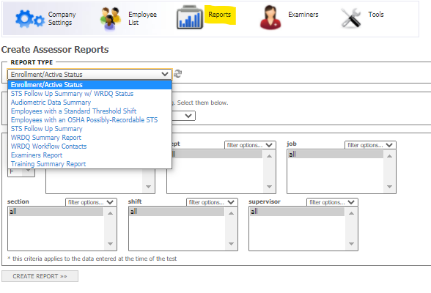

If you get a message saying “your report will pop up in a minute, please wait” for longer than 10 seconds, you may want to check if your pop-up blocker is active. If so, please turn it off to get a report. To print, click the printer icon on the top left corner of the report.

Scheduling Reports

AudioAssessor© also allows you to track the scheduling of your employees offering alternative reports such as Active employees who haven’t been tested in over one year, Active employees due to be tested based on their test cycle, Employees last tested on XX date. To access these reports, select the “Tools” icon on the horizontal menu bar at the top of the page, select “Scheduling Reports” and enter your criteria into the search fields.

Where to find Scheduling Reports:

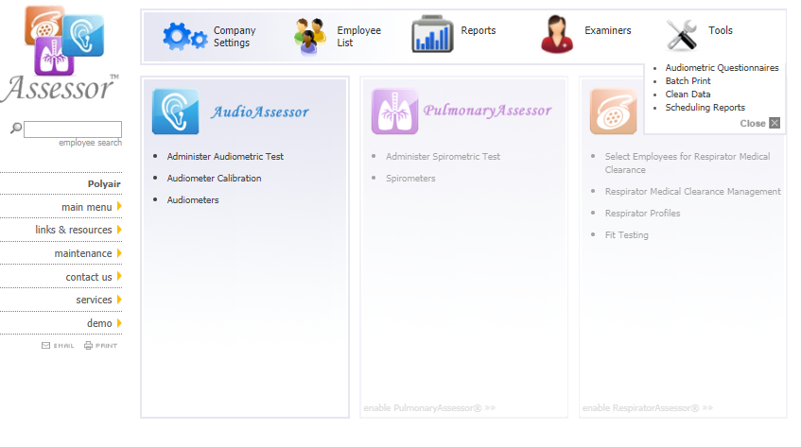

Selecting Search Criteria:
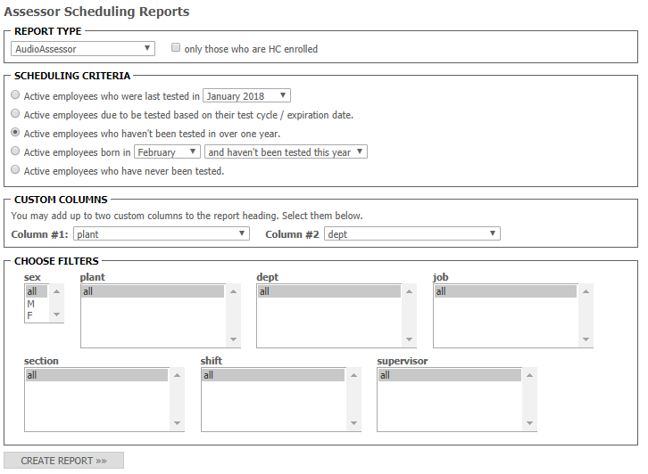

This report allows you to easily inactivate employees who may no longer work for your company or who have been removed from the hearing conservation program. Just simply click the check box next to their name and then select “Click to Deactivate the Selected Users”.
Notification Reports and Batch Printing

Individual Employee Notification Forms are generated for each employee. AudioAssessor© has the ability to
adjust each test appropriately for age correction and these values are exhibited on each notification letter. A batch print function is available allowing the user to print multiple employee notification reports simultaneously. This report can be filtered by a specific date range as well as any customized filters that are enabled for the user’s account.

