Step 1: Login to https://assessor.ei1.com/
Step 2: Click Administer an Audiometric Test
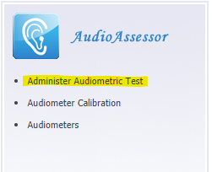

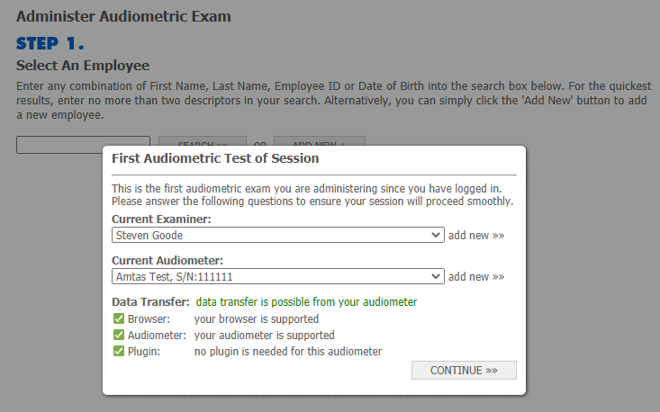
Step 3: If this is the first test of the day, the “First Audiometric Test of Session” box will appear. Select the Examiner (the examiner conducting the hearing test) and the Amtas audiometer and click continue.

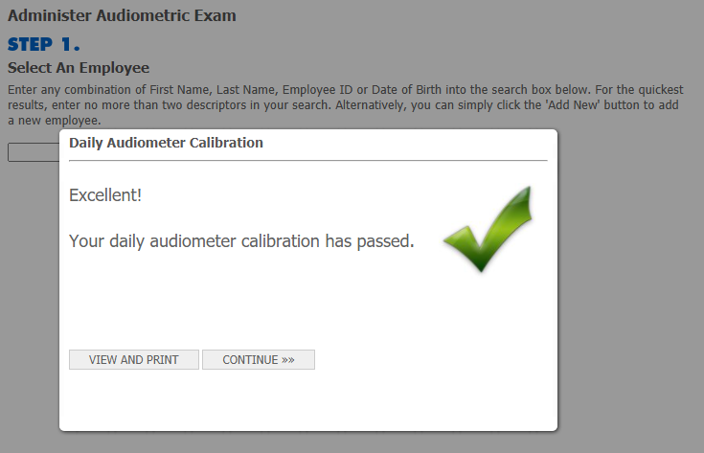
Step 4: If the Daily Calibration has not been completed for today the calibration window will appear. Please refer to the guide “AudioAssessor Calibration Process for Boothless Flex Audiometer” to complete the calibration.

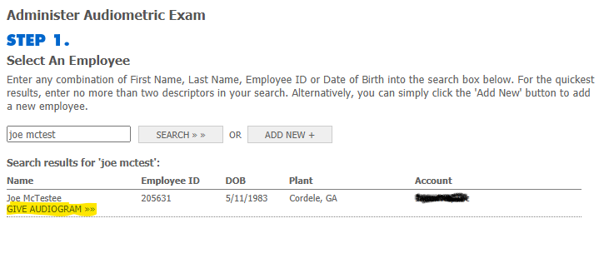
Step 5: Search for the employee to be tested and click “GIVE AUDIOGRAM>>”

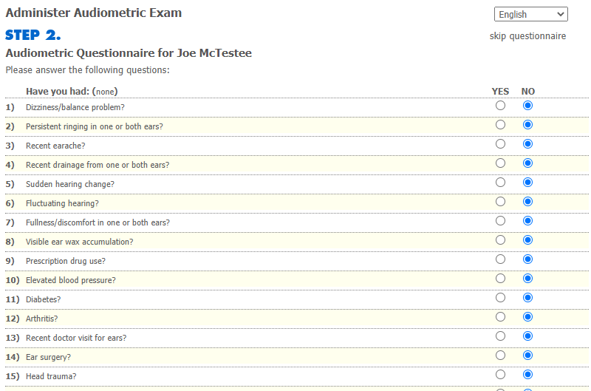
Step 6: Complete the Audiometric History Questionnaire and click continue at the bottom of the page.

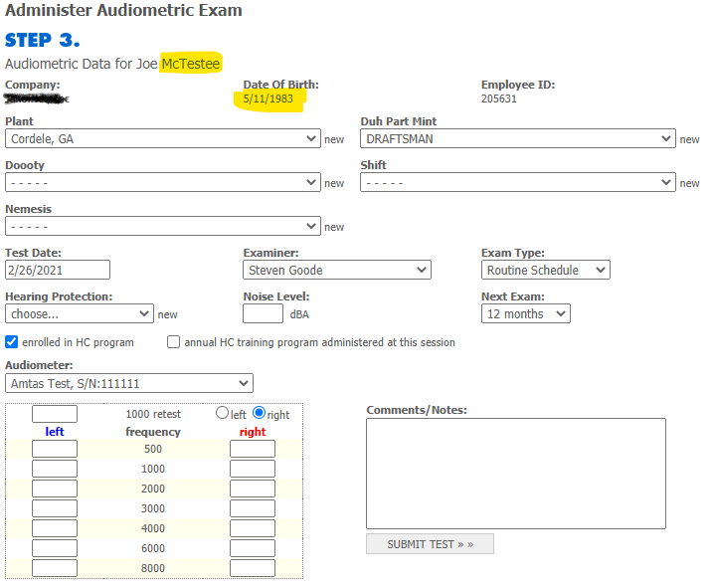
Step 7: On the Administer Audiometric Exam verify the employee’s Last Name and DOB.

Step 8: Go to the Amtas Flex and enter the Employee Name and DOB. These should match the information from Step 7. It is very important that these values match. Complete the hearing test.
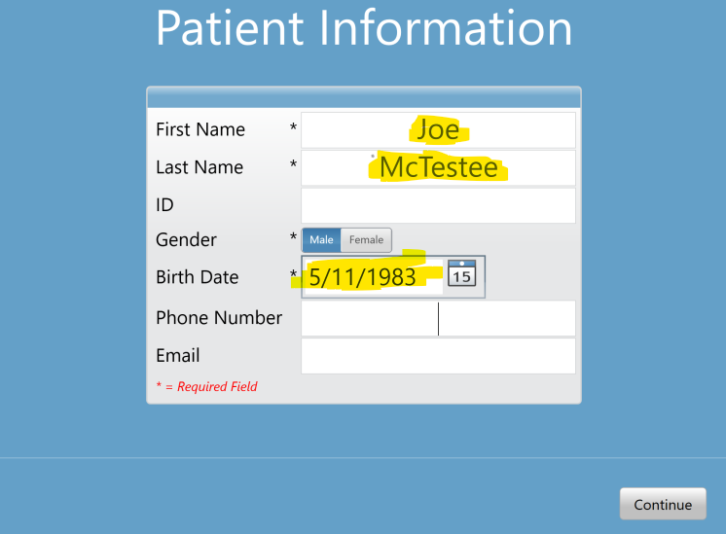

Step 9: Redirect your attention to the “Administer Audiometric Exam” page on the computer. Once the test is complete the Amtas Flex will automatically upload the test to AudioAssessor. This can take up to two (2) minutes. This occurs in the background. The test values will automatically appear in the window. There is no need to refresh or reload the page. Click Submit Test.
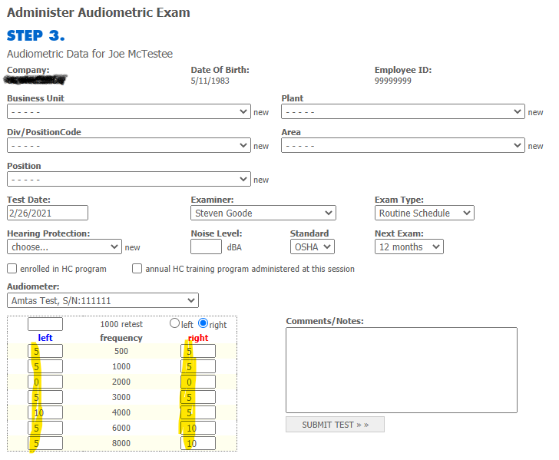

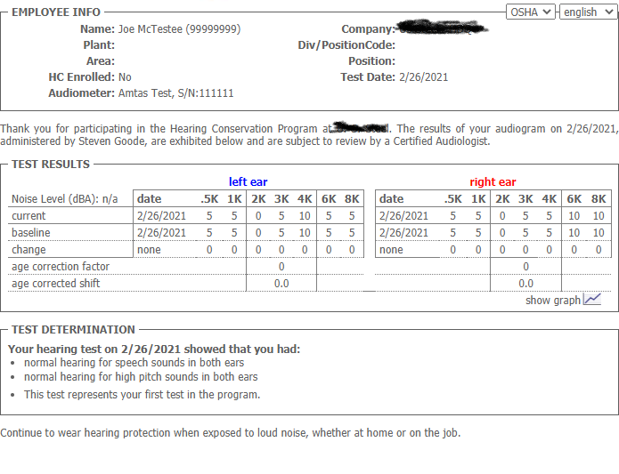
Step 10: A notification report should pop-up. You are done!

