How to Submit a Work Relatedness Determination Questionnaire (WRDQ)
- Login to https://assessor.ei1.com/ If you have forgotten your password, please use the forgot password function.
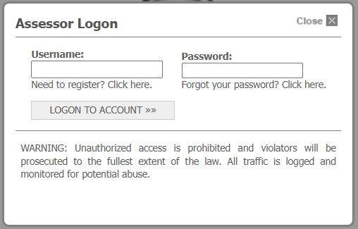
- In the top left of the screen, find the search field. Search for and select the name of the employee in question to open the employee’s record. It is important that you select employee search directly below the search field.
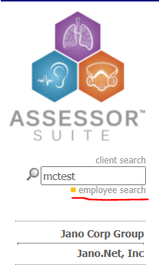
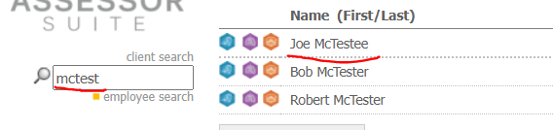
- Scroll down to the Audiometric Results section of the employee’s record. It should be a section that looks like this…
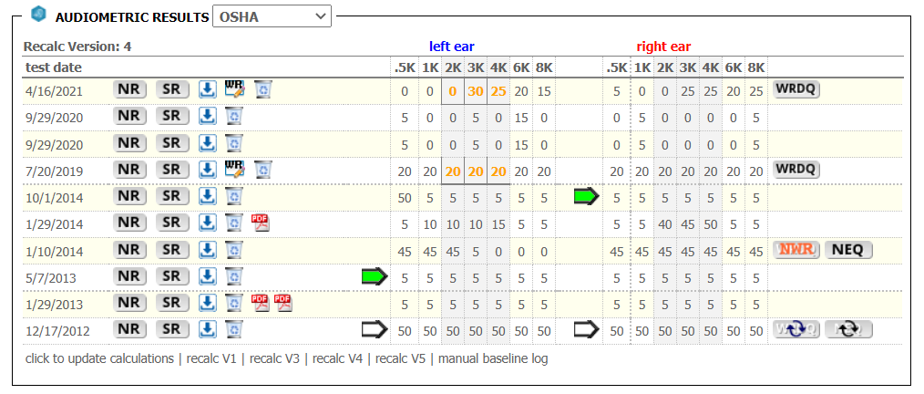
- You will notice that there is a small radial button labelled WRDQ located in the top right of the employee’s most recent test results. Clicking this button will activate a popup window containing the questionnaire.
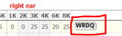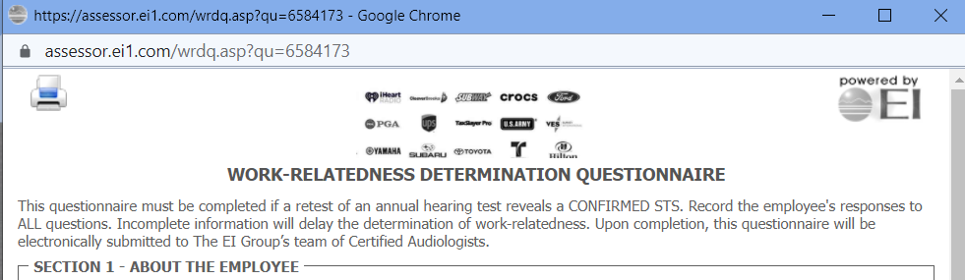
The popup should have this header.
- You have the option to either “Submit NEQ Request” or “Submit Questionnaire” located at the bottom of the WRDQ form.
- Once submitted, the questionnaire will appear in EI’s audiologists’ queue for review. After the audiologist has reviewed the record and submits the determination, an email will be sent to the primary point for contact for the client as well as the interviewer listed on the questionnaire (if different from the review email recipients).

